Here are 8 steps of an effective ETL testing process.

Identify your requirements
Assess your data sources
Create test cases
Extract that data
Transform that data
Load that data
Document your findings
Conclude testing and proceed with ETL.
Check that all expect data is loaded into target database.
Compare the number of records between source and target tables.
Check if there are any rejected tables.
Check that the data is displayed in full in target database.
Check boundary value analysis.
Compare unique values of key fields between source and target tables.

ETL Testing – Techniques

Source-to-target Count Testing :-

once records load in to target table we need to check the number of record loaded in target table. source record count and target record count has to match.

Source-to-target Data Testing :-

In these testing we need add some invalid records in our source file like null records, not null, invalid date formate, if accepted value is string we need to give decimal value in this place, if accepted value is decimal we need to give string value in this place, Duplicate records, delimiter validation.

Data Integration / Threshold Value Validation Testing :-

This is usually done by checking the following: if data loads and queries are executed within the expected timeframe. if the maximum data volume is loaded within the expected timeframe. load times for different data volumes.

Application Migration Testing:-

Migration Testing is a verification process of migration of the legacy system to the new system with minimal disruption/downtime. Ensure the data integrity, no loss of data, all the functional and non-functional aspects of the application are met post-migration.

Data Check and Constraint Testing :-

Validate Constraints. It involves validating the constraints and ensuring that they are applied on the expected tables. Data Consistency check. It involves checking the misuse of integrity constraints like Foreign Key.

Duplicate Data Check Testing :-

We can detect duplicates by first declaring columns that are supposed to be unique as the primary key and create an SQL query in the transformation that will test and compare each and every row for duplicates. We can also work with ETL-tools deduplicator.
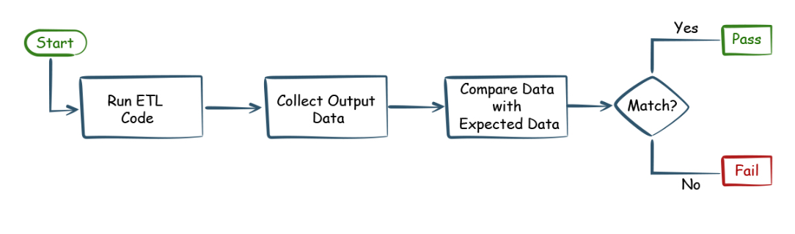

Data Transformation Testing

The 5 steps of the ETL process are: extract, clean, transform, load, and analyze. Of the 5, extract, transform, and load are the most important process steps. Clean: Cleans data extracted from an unstructured data pool, ensuring the quality of the data prior to transformation.


